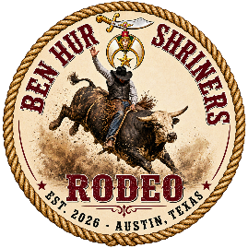
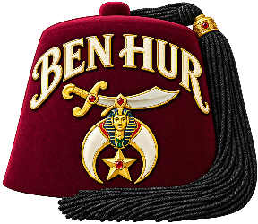
2026 Ben Hur Rodeo
Sponsorship Packet
October 24, 2026 • Broken G Rodeo Facility, 258 N Hwy 183, Liberty Hill, Texas

Overview
The Ben Hur Shriners will host the 2026 Ben Hur Rodeo on October 24 — a one-day bull riding event featuring a calf scramble and mutton busting for younger attendees.
In addition to the rodeo action, attendees will enjoy live music, concessions, a VIP hospitality area, and other family-friendly attractions.
The Rodeo will be held at the Broken G Rodeo facility, 258 N Hwy 183, Liberty Hill, Texas.

Our Vision
Our vision is to grow the Ben Hur Rodeo into a premier multi-day event in future years — drawing more families with affordable admission and up-close rodeo action. Sponsorship opportunities like these help us highlight local and regional businesses while bringing that vision to life.
Your current and future support of this non-profit fundraising event will help make it happen.

Sponsorships
Business, organization, and personal sponsorships help offset the cost of bringing the 2026 Ben Hur Rodeo to families in the Austin area. We're offering a range of sponsorship opportunities and invite you to choose the one (or more) that best fits your business or organization. The following sponsorship opportunities are still available:
Sponsorship | Price | Available | Includes | Additional VIP
Fez Sponsor | $3,000.00 each | 2 available | Two 3′×5′ arena signs; eight VIP tickets; second-tier sponsor recognition on social media and announcements across all events | $125.00 each (max 6)
Bucking Chute Sponsor | $1,500.00 each | 5 available | One bucking chute sign; one 3′×5′ arena sign; four VIP tickets; sponsor recognition on social media, during the event, and each time the signed chute is used | $175.00 each (max 4)
Band  Sponsor | $1,000.00 each | 1 available | One 3′×5′ arena sign; One sign near stage, four VIP tickets; sponsor recognition on social media and while the band is playing and during the event. | $175.00 each (max 2)
Bronze Sponsor | $500.00 each | Multiple available | One 3′×5′ arena sign; two VIP tickets; sponsor recognition on social media and during the bull riding event | N/A
Design-your-own  Sponsor | $ | Multiple available | Describe proposed sponsorship | N/A
All arena signs are approximately 3′×5′. "Additional VIP" pricing lets a sponsor purchase more VIP tickets beyond the number included in their package, up to the stated maximum.
Discuss Design-your-own sponsorship opportunities with your salesperson!

Ticket Pricing
Attendees can purchase tickets online before the Rodeo or at the gate the evening of the event. Online tickets are available on Ben Hur’s website http://www.benhurshrine.org/rodeo.
Ticket Type | Price | Notes
VIP Admission | $200.00 | Includes food and drinks in a private area adjacent to the arena
Adult General Admission | $15.00
First Responders & Military (with ID) | $10.00
Children | $5.00
VIP Admission includes all food and drinks in a private area adjacent to the arena and action.

In Closing
The Ben Hur Shriners appreciate the time you've taken to consider a sponsorship. We hope you'll join us in bringing this affordable rodeo event to families in our area, while putting your business or organization in front of our community.

Together, we will make the 2026 Ben Hur Rodeo a success!

Have questions – Send them to BenHurRodeo@outlook.com
Proceeds are for the benefit of Ben Hur Shriners’ activities and are not deductible as charitable contributions.

